Chapter 2 Specification Requirement

2.1 Use Case Scenario

2.1.1 Feature 1

2.1.1.1 Actor
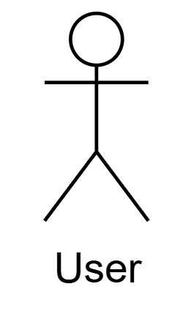

2.1.1.2 Use Case Diagram
Feature 1: Daily Briefing System
At 8 a.m. every day, the system captures news from the pre-approved websites of the Thai government/mainstream media (Bangkok Post, The Nation Thailand), and saves each article as a Daily Briefing record, including original title, summary generated by the system call Qwen Ai to summarize, source website name, original URL, publication time provided by the source, crawl timestamp. The system generates both Chinese and English versions for the title and abstract, and the interface only displays one of them in the current language. When the International Student opens the Daily Briefing page, the system returns a paginated list from new to old according to the release time. The list card displays: title, summary, source, publication time (using only the current interface language), and provides a button to enter the detail page. International students click on a certain item to enter the Daily Briefing detail page. The system displays the Daily Briefing title, content of AI summary Daily Briefing, Daily Briefing release time (in original website), capture time (Every morning at eight o 'clock) of this news item, as well as a "View Original" button. After the button is clicked, the system opens the original URL of the news in a new TAB in browser. International student can enter Chinese or English keywords in the search box on the page. Search among the Daily Briefing existing Chinese and English titles and Daily Briefing abstracts in the database, return the matching Daily Briefing list, and display the results that match the keywords in the current interface language (English/Chinese). International student can set filtering conditions: start date(day-month-year), end date(day-month-year), and source (selected from the predefined Bangkok Post, The Nation Thailand list). The system applies all filtering conditions, only returns the news that meets the conditions, and displays them in chronological order(new to old). International student can click the language switch button to switch between Chinese and English. The system will immediately refresh the interface text and select and display the title and summary in the corresponding language (Chinese/English) for each piece of news in the current list/details (only one language is displayed).
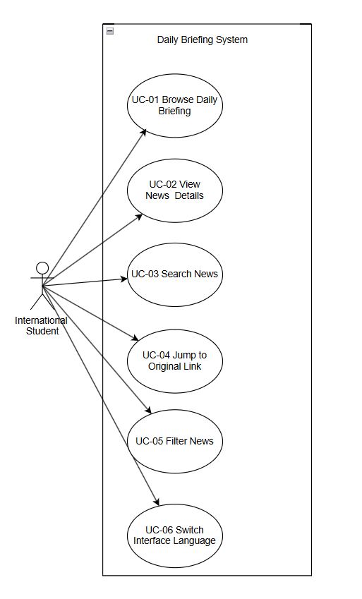

2.1.2 Feature2

2.1.2.1 Actor


2.1.2.2 Use Case Diagram
Feature 2: Community Interaction
International Students and Merchants can open the community page and see the stream of post which post time from new to old. Scrolling down will load more posts. Each post card shows title, preview of the main text, selected tags (Study, Housing, Travel, Part-time Job), number of likes, and number of comments. Users can click on post to enter the post details page. On the post detail page, International Students and Merchants can view the full text about this post, pictures, tags(such as learning), total number of likes, total number of comments. Clicking on the author's avatar can show the author's profile(avatar,name,author’s posts). The detail page also supports subsequent operations: liking(click “like” button to like post), commenting (International Students and merchants can enter Chinese/English comments under a certain post, along with the commenter's name and timestamp.), reporting- in the reporting form, select one or more predefined reasons (Spam, Fraud or Scam, Illegal Service Promotion, Abusive Language, Other), and you can fill in the explanatory text. After submission, it enters the subsequent review (the human administrator will judge whether the post/comment involves illegal service promotion, fraud or scam information, spam advertising, hate speech abusive language, pornography, or any other content that violates Thai law or university policies). If there is, it is not allowed to be sent out; if not, it is allowed to be sent out. If you have followed each other) sending a private message directly to the author.
International Students and merchants can create or edit their own posts: enter Chinese/English titles and text, upload pictures, and select tags (such as Learning). When submitting for release, the system will call Qwen Ai to automatically translates and generates another language version and conducts a content security review (A post must not contain illegal service promotion, fraud or scam information, spam advertising, hate speech pornography, or any other content that violates Thai law or university policies).
In the community page, international Students and Merchants can enter Chinese/English keywords. The system will search in all post titles and body texts (in both Chinese and English versions) and only return the list of matching posts. For International Students/merchants who follow each other, both sides will appear in each other's mutual follow list. Open the mutual follow list.
International Students/Merchant can search for the names of those they follow, view their profiles(name,their posts), send private messages directly from the list or unfollow those they already follow. International Students and merchants can open existing one-on-one private messages or create new one-on-one private messages, send and receive messages with mutual followers, and view the history in the conversation interface.Mark the session as read/unread in the session list, or delete the entire session so that it no longer appears in the list.
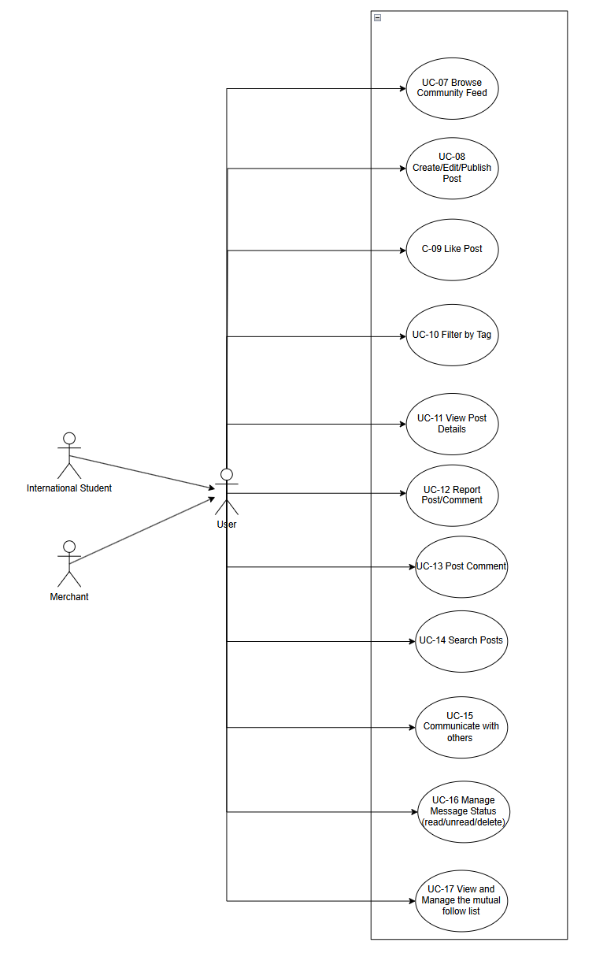

2.2.3 Feature 3

2.2.3.1 Actor

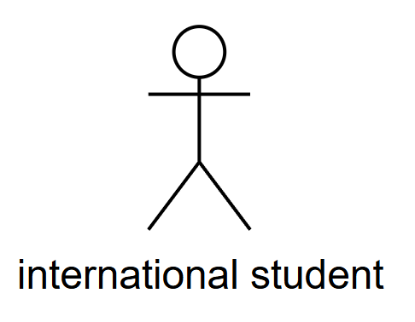
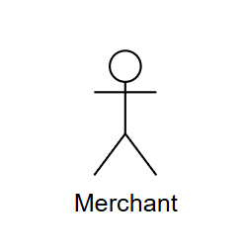

2.2.3.2 Use Case Diagram
Feature 3 provides an authentication and profile system that lets International Students and Merchant register new accounts with different methods（school email address for International Students or phone number for Merchant）, log in and log out securely, and manage their own profile information and community posts,a password, a display name, an optional avatar image, and a preferred interface language (Chinese or English).When new users register, International Students select "Student Registration" and enter their school email address (such as an email ending.edu) in the registration form. The system sends a verification code email to the school's email address. Students enter the received verification code on the page, then set a password, fill in the display name and select the interface language. After submission, the system creates a new account for this email address. For Merchant, select "Merchant Registration" and enter your mobile phone number in the registration form. The system sends a text message containing a verification code to this mobile phone number. The merchant enters the received verification code on the page, then sets a password, fills in the display name and selects the language interface.
After submission, the system creates a new account for this mobile phone number. Registered International Students and merchants open the login page and enter their respective account identifiers and passwords in the login form: students use the school email address used during registration, and merchants use the mobile phone number used during registration. The system verifies the credentials. Once the verification is successful, the user will be redirected to the community system page.When logged in, International Students and Merchants can click the "Log Out" button to end the current session. The system clears the login status and returns to the login page. If they want to use the system again, they need to re-enter the account identifier and password to log in.
After logging in, International Students and Merchants can open the "Profile" page to view the name, avatar and own posts saved in the current account. International Students and Merchants can enter the "My Community Posts" list from the profile module. The system displays all community posts published by the current account in this list. Each post shows its title, publication time, and current review status (published, pending review, or rejected). Users can browse these records to learn about the publication and review of their content in the community.Users can modify these fields on the page and submit the form. The system updates the account information with the new values. After refreshing the page, users can see the latest information.

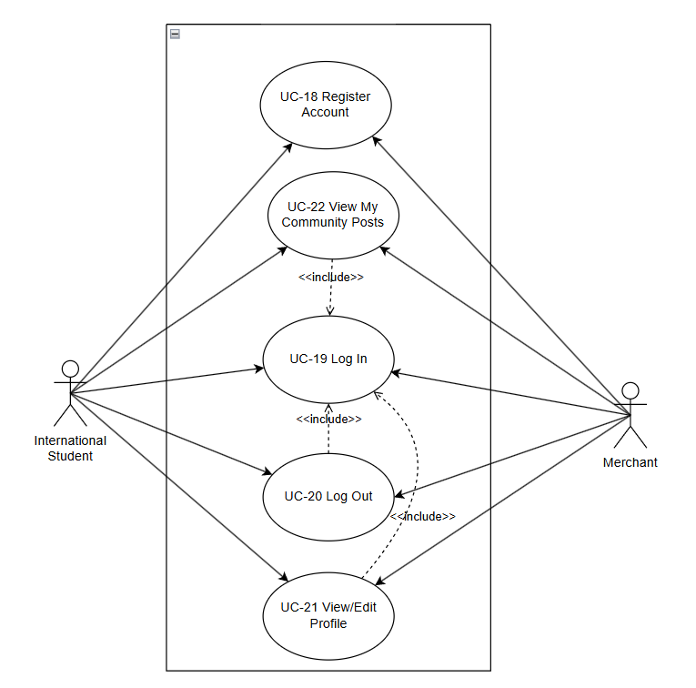

2.2 User Requirement Specification
Feature 1:
URS-01 – Browse Daily Briefings
International Students can open the Daily Briefing page and browse a paginated list of recent Daily Briefing items ordered from newest to oldest by publication time in their current interface language.
URS-02 – View news details
International Students can select a Daily Briefing item from the list and view a news detail page that shows the complete information (title, summary, publication time, crawl time, View Original button) for that item in their current interface language(English/Chinese).
URS-03 – Search for News
International Students can type Chinese or English keywords into a search box on the Daily Briefing page and view only Daily Briefing items that match the entered keywords.
URS‑04 – Jump to the original link
International Students can click an “Open original article” button on a Daily Briefing item and read the full original news article on the external official website in a new browser tab.
URS‑05 – Filter News
International Students can filter Daily Briefing items by choosing a start date, an end date, and news sources from a predefined list(Bangkok Post, The Nation Thailand), and then browse only the items that meet these filter conditions.

URS‑06 – Switch Interface Language
International Students can click a language switch button at any time to change the interface language between Chinese and English and continue browsing Daily Briefing items in the newly selected language.

Feature 2:
Feature 2 - Community Interaction
URS‑07 – Browse Community Feed
International Students and Merchant can open the community page and view a continuously updated feed of approved community posts authored by International Students and Merchant, ordered from newest to oldest by publication time, where each post card shows the title, a preview of the body text, selected tags, the number of likes, and the number of comments.
URS‑08 – Create/Edit/Publish Community Post
International Students and Merchant can create a new community post or edit one of their existing posts.
International Students and Merchant can enter the post title and body in either Chinese or English, upload images, and choose tags (such as “Learning”) from the predefined tag list.
International Students and Merchant can submit the post for publishing, and the post is published to the community feed only after it satisfies the safety rules (A post must not contain illegal service promotion, fraud or scam information, spam advertising, hate speech) defined by the moderation process.
URS‑09 – Like Post
International Students and Merchant can express positive feedback on a specific community post by clicking a like button, and they can see the like count on the post updated accordingly.
URS‑10 – Filter by Tag
International Students and Merchant can focus on posts belonging to specific topics by selecting tags from the predefined tag list (for example “Study”, “Housing”, “Travel”, “Part‑time Job”).
After International Students and Merchant select tags, they can see the community feed showing only posts that contain at least one of the selected tags.
URS‑11 – View Post Details
International Students and Merchant can open a single community post from the feed and see the full body text, all images, the tags (such as “Learning”), detailed engagement metrics (total likes and total comments), and a link to the author’s profile.
International Students and Merchant can click on the author's avatar to view the author's profile (avatar, name, author's posts).If International Students and Merchant have a mutual-follow relationship with the author, they can send a private message directly to the author from the post detail page.
URS‑12 – Report Post/Comment
International Students and Merchant can submit reports about suspected spam, fraud, illegal service promotion, or abusive language on a specific community post or comment.
International Students and Merchant can choose one or more predefined report reasons, such as “Spam”, “Fraud or Scam”, “Illegal Service Promotion”, “Abusive Language”, or “Other”, and can optionally enter additional description text before sending the report for later moderation.
URS‑13 – Post Comment
International Students and Merchant can add comments under a selected community post.
International Students and Merchant can enter the comment text in Chinese or English and submit it, and then they can see the new comment appearing in the comment list below the post together with the commenter’s name and timestamp.
URS‑14 – Search Posts
International Students and Merchant can search for community posts by entering keywords.
International Students and Merchant can see only posts whose Chinese or English titles ,body texts in contain the entered keywords.
URS‑15 – Communicate with Mutual‑Follow Partners
International Students and Merchant can communicate privately with accounts on their mutual‑follow list.
International Students and Merchant can open an existing one‑to‑one conversation or create a new conversation with a mutual‑follow partner, send and receive messages, and view the conversation history in a chat interface.
URS‑16 – Manage Message Status
International Students and Merchant can manage the status of their messages and conversations.
International Students and Merchant can mark conversations as read or unread, and they can delete an entire conversation from their own conversation list so that it no longer appears in the chat overview.
URS‑17 – View and Manage Mutual‑Follow List
International Students and Merchant can open a dedicated mutual‑follow list page that shows all accounts that have established a mutual‑follow relationship with the current account.
From this page, International Students and Merchant can search within their mutual‑follow partners, open a partner’s profile, remove the follow relationship, or start a private conversation with a selected partner.

Feature 3:
URS‑18 – Register Account
International Students can create a new user account by entering their school email address (for example, an email address ending with .edu ). International Students receive a verification code sent to their school email address, enter the received verification code, set a password, choose a display name, and select their preferred interface language (Chinese or English) to complete registration.
Merchants can create a new user account by entering their phone number. Merchant receives a verification code via SMS sent to their phone number, enter the received verification code, set a password, choose a display name, and select their preferred interface language (Chinese or English) to complete registration.
URS‑19 – Log In
International Students can log in to the system by entering their registered school email address and password.
Merchants can log in to the system by entering their registered phone number and password.

URS‑20 – Log Out
International Students and Merchant can log out from the system by clicking a logout button, and then they are redirected to the login page and must log in again to access the system.
URS‑21 – View and Edit Profile
International Students and Merchant can open their personal profile page to view their stored account information, including display name, avatar, and preferred interface language.
International Students and Merchant can edit any of these profile fields by entering new values and submitting the changes.
URS‑22 – View My Community Posts
International Students and Merchant can open a dedicated list page under their profile to view all community posts created by their current account.
International Students and Merchant can see each post’s title, publication time and current moderation status (published, pending review, or rejected) on this list page.

User Journey
